Portable Measurement Arm Joint Design

Draft Project Proposal

LN Matota
24989142

Supervisor: Prof K. Schreve

2026

Plagiarism declaration
I have read and understand the Stellenbosch University Policy on Plagiarism and the definitions of plagiarism and self-plagiarism contained in the Policy [Plagiarism: The use of the ideas or material of others without acknowledgement, or the re-use of one's own previously evaluated or published material without acknowledgement or indication thereof (self-plagiarism or text-recycling)].
I also understand that direct translations are plagiarism, unless accompanied by an appropriate acknowledgement of the source. I also know that verbatim copy that has not been explicitly indicated as such, is plagiarism.
I know that plagiarism is a punishable offence and may be referred to the University's Central Disciplinary Committee (CDC) who has the authority to expel me for such an offence.
I know that plagiarism is harmful for the academic environment and that it has a negative impact on any profession.
Accordingly all quotations and contributions from any source whatsoever (including the internet) have been cited fully (acknowledged); further, all verbatim copies have been expressly indicated as such (e.g. through quotation marks) and the sources are cited fully.
I declare that, except where a source has been cited, the work contained in this assignment is my own work and that I have not previously (in its entirety or in part) submitted it for grading in this module/assignment or another module/assignment.
I declare that have not allowed, and will not allow, anyone to use my work (in paper, graphics, electronic, verbal or any other format) with the intention of passing it off as his/her own work.
I know that a mark of zero may be awarded to assignments with plagiarism and also that no opportunity be given to submit an improved assignment.

Signature:

Name: Student no:

Date:

Artificial Intelligence (AI) declaration

Declaration
☐ I have discussed the use (or non-use) of GenAI tools with my supervisor, and we have agreed on appropriate boundaries.
☐ I have verified and take responsibility for all information, arguments, data, and conclusions in this thesis/dissertation. I am accountable for the integrity of the work.
☐ I confirm that AI tools were not used in ways that breach SU’s plagiarism, confidentiality, or research integrity policies.
☐ No data were generated by GenAI unless this was a deliberate and declared part of the research methodology.
☐ I am willing to be questioned in the oral examination on the scope, purpose, and verification of any GenAI use in this work.

Optional:
☐ I have included a reflective paragraph in my submission explaining the role (if any) of GenAI in my research process.

Institutional Acknowledgement
This declaration aligns with Stellenbosch University’s Position Statement on the ethical use of AI in Research and Teaching-Learning-Assessment, the Draft interim SU guidelines on allowable AI use and academic integrity in assessment, and draws on international best practices.

Abstract
For PhD project proposal: approximately 200 words in narrative style. Must be the same as the executive summary (PG07 document).
For PhD dissertations, masters thesis, and other research assignments: not more than 500 words in narrative style.
For Skripsie (final year BEng) project, replace the Abstract with the Executive summary as per the module framework.

Acknowledgements
D

Table of contents
Page
Plagiarism declaration i
Artificial Intelligence (AI) declaration ii
Declaration ii
Optional: ii
Institutional Acknowledgement ii
Abstract iii
Acknowledgements iv
Table of contents v
List of figures vii
List of tables viii
List of symbols ix
1 Introduction 1
1.1 Background 1
1.2 Aim and Objectives 1
1.3 Scope 1
1.4 Motivation 1
1.5 Use of AI Tools 1
1.6 Report Overview 1
2 Literature review 2
2.1 Example heading level 2 2
2.1.1 Example heading level 3 2
2.1.2 Another heading level 3 2
2.2 Tables and figures 2
2.3 Creating numbered equations 4
2.4 Ethical Considerations 5
3 Research Methodology 6
4 Workplan 7
5 Resource Requirements 8
6 Expected Results 9
7 Project Schedule 10
8 Risk Assessment 11
9 Conclusions 12
References 13
Appendix A This is an Appendix 14
Appendix B Heading for this appendix 15
B.1 Bla bla 15
B.1.1 Bla bla 15

List of figures

Page
Figure 1: Water plants 5

List of tables

Page
Table 1: Acceptable page layouts 4

List of symbols

A Wing area
c Chord length
α Angle of attack

Introduction

Background
Portable Measurement Coordinate Arms (PMCAs), also referred to as Articulated Arm Coordinate Measuring Machines (AACMMs) in literature, offer flexible metrology in multiple environments. However, these machines have a reliance on “human” actuation that introduces a large amount of uncertainty in the measurements they take. The main limitation of these joints is the “human factor”, so to speak, in which operators often introduce fluctuating contact forces, positional instability, and unpredictable probing trajectories that can cause dynamic structural deformations of the arm, (B.J. Alvarez, 2015). In addition to this, the accuracy of PMCAs is dependent on robust kinematic calibration procedures that map out the geometric parameters and encoder errors of each rotary axes along the length of the arms, (S. Ibaraki, 2023) (A. Brau, 2014). The calibration routines require the arm to be held completely rigid during the process. This means that the lack of a position-holding mechanism makes the system susceptible fatigue and damage that is human in origin. As a result, designing an effective joint with a position-holding mechanism is an important engineering requirement. By designing the joint in this manner, the measurements will become independent of human error, which create kinematic stability, improving the repeatability and accuracy of the arm.

Aim and Objectives
The aim of this project is to implement a position-holding mechanism on the joint of a portable measurement coordinate arm without jeopardising its accuracy.
The objectives of the project include the following points:
1.2.1. To maintain accuracy in the working volume of the PMCA.
1.2.2. To make the joint design modular and applicable to a range of PMCAs.
1.2.3. To propose a calibration and/or testing procedure for the arm given the implemented joint design

Scope
The project will conduct a kinematic and force analysis on the arm.

Motivation
Why this specific project/report is worthwhile.

Use of AI Tools
Give a brief statement of how AI tools, if any, were used in this project, including grammar checking (e.g. Grammerly), coding assistance (e.g. copilot), etc.

Report Overview
Give a short overview of the chapters of the report.

Literature review
This chapter reviews the "state of the art" and summarises the work of others used in this project.
Unless the chapter heading already makes it clear, an introductory paragraph that explains how this chapter contributes to the objectives of the report/project.

Example heading level 2

Example heading level 3

Deepest heading, only if you cannot do without it
"Text 1" is for normal paragraphs. A blank line is automatically created before each paragraph.
1. "Text 1 Items" for a list that is not automatically numbered.
2. List that is not automatically numbered.
3. List that is not automatically numbered.
"Text 2" is for a paragraph that fits under "Text 1 items".

Another heading level 3
Waffle waffle
- "Text 1 bullet" for a bulleted list;
- Bullet list item 2;
- "Text 2 bullet" for sub-points
- "Text 2 bullet" for sub-points
- Bullet list item 3.
"Text 2" also fits under "Text 1 bullet".

Tables and figures
The body text should refer to each figure (e.g. Figure 1) and each table (e.g. Table 1). Note that Word's default cross-reference for tables and figure includes the whole caption and, therefore, the setting must be changed to "Only label and number".
Table 1: Acceptable page layouts (manually set "keep with next" in paragraph style for tables)
Paper | Margins
 | Left/Right [mm] | Top/Bottom [mm]
A4 | 35/35 | 26/44
A5 | 17/17 | 22/22
If sketches and diagrams are created in PowerPoint or Visio, select the whole figure in the software used to create it, copy it to the clipboard (Cntl C) and in Word select "Paste special" to insert it as "Picture (enhanced metafile)". If other software is used for diagrams or figures, saving them to the "png" file format usually works best. The paragraph containing the figure should use the "Figure" style. If you type "Enter" in the "Figure" style, the next style is automatically "Caption". Set the "Wrap Text" option to "Inline with text". In the final formatting stage of the report, if there is too much white space between the test before the figure and the bottom of the page (because the figure "jumped" to the next page), move a paragraph of text from below the figure to above it.
In this template, the Caption style is left-justified as a matter of convenience (so that the “Insert Caption” dialog shows the caption left-justified too). The final version of the report can use left-justified or centred captions. It is important that the style is consistent throughout the report.
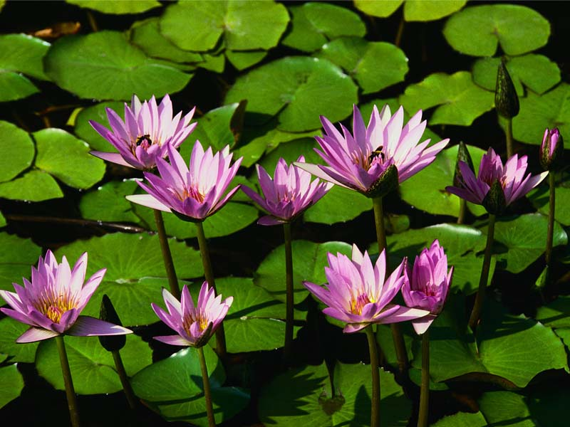
Figure 1: Water plants

Creating numbered equations
An equation must read like part of the text. For example, Newton's second law can be expressed as follows (note the full stop after the equation to indicate the end of the sentence):
 | $F=m\dot{v}$. | (1)
In other cases, the equation is in the middle of the sentence. For example, Newton's second law can also be expressed as
 | $$F=m\ddot{x}$$ | (2)
where $\ddot{x}$ represents linear acceleration. Note that this line starts with a small letter because it continues the sentence containing the equation.
To create equations with equation numbers that can be cross-referenced:
- Copy the whole line of one of the above equations to where the new equation must be inserted. Note that the equation is in a table with invisible borders and the whole table must be copied.
- Edit or replace the equation.
- Update the equation number by highlighting it and pressing F9.
To create an equation from scratch requires a few steps. Equations (1) and (2) are each in the middle column of a three-column table, with the equation numbers in the right-hand column. The table format was set to hide the table's grid lines. To view the grid lines on screen, but not in print, toggle "View Gridlines" on the dropdown list where grid lines can be turned on or off. To create the equation number, place the cursor on a blank line below the table, click the "Insert Caption" button on the "References" tab and select the custom "(" label, which was created for these numbers. Manually add a ")" to the caption. Then cut the number with its brackets and paste it all into the right-hand column of the table. Ensure that the paragraph in the right-hand column is right-justified.
To insert a cross-reference to an equation, the "Cross-reference" button on the References tab can be used, selecting "(" as "Reference type" and adding the closing bracket manually.

Ethical Considerations
For biomedical engineering projects, from the literature, discuss the ethical considerations for the execution of this project.

Research Methodology
Describe the research methodology that will be used in this project. Typically 1 to 2 pages.

Workplan

Conduct Research and Review Literature
This would include looking into industry and obtaining at most, 3 of the most used PMCA models for analysis

Investigate Existing Solutions in Industry
This would include doing comparative analysis across the available options, weighing pros and cons and determining whether the technology can be applied for such purposes.

Define the Design Requirements for the System

Evaluate Possible Solutions Against Design Requirements
Weigh out pros and cons. Mathematical calculations and datasheets will help create benchmarks, tolerances and/or limits of performance on the joint. The best joint design will also work the best on all 3 PMCAs models. Techno-economic analysis must be conducted as well.

Create a Model/Simulate of the Joint Design
Simulate the best joint with the three PMCAs and

Validate the Model of the Joint Design
Analyse the kinematics and possible forces acting on the arm

Build and Test the Joint design

Share Findings

Resource Requirements

Expected Results
Briefly describe the expected results.
For PhD proposals, the unique contribution should be stated here, as well as the planned publication outputs. Publication outputs should be the same as in the Executive Summary (PG07). Title and journal/conference name should be listed. Typically 1 page or less.

Project Schedule
Give a Gantt chart. The tasks in the Gantt chart should be the same as those of the workplan (section 4). Typically 1 page. Basically just the Gantt chart.

Risk Assessment
Use a risk matrix to summarize the project risks. Risk rating and mitigation should be given. Use the table below. Typically 1 to 2 pages.
The Impact Scale: Negligible (1), Low (2), Moderate (3), Significant (4), Catastrophic (5).
The Likelihood Scale: Very Unlikely (1), Not likely (2), Possible (3), Probable (4), Very Likely (5).
Risk Rating: Low = [1-8], Moderate = [9-16], High = [17-25].
The Impact is multiplied by the Likelihood to determine the Risk Rating.
For example: Negligible (1) x Possible (3) = Low Risk (3)
Table 2 Risk Assessment
Risks (add columns as necessary, or use multiple tables)
Activity
Risk
Impact
Likelihood
Risk Rating
Mitigation

Conclusions
Refer to the corresponding section in the Guide for Writing Technical Report for advice on what to include in this section. Typically 1 page or less.

References
B.J. Alvarez, E. C. P. L. D. M. &. D. M., 2015. Dynamic Deforemations in Coordinate Measuring Arms using Virtual Simulation, Gijon: Dept. of Construction & Manufacturing Engineering, University of Oviedo.

This is an Appendix
Note that for appendix headings use styles "Heading 1 app", "Heading 2 app", etc.
Note that all headings must have a title, just as a chapter has a heading

Heading for this appendix
Intro paragraph of appendix

Bla bla

Bla bla
asda

Position Statement on Ethical use of Artificial Intelligence in Research and Teaching-Learning Assessment
Draft interim SU guidelines on allowable AI use and academic integrity in assessment
The activities should be the same as those of the workplan (section 4).

